# How to generate a RSA key pair

1. Download puttygen, or use a computer in York Road as they already have it installed
2. Open puttygen and make sure it the settings are set to the following

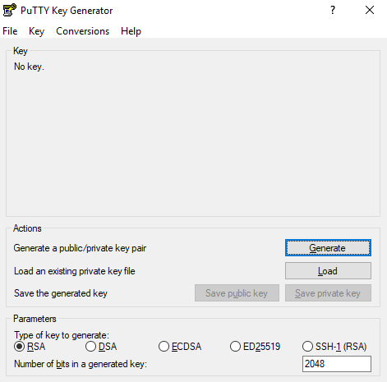

1. Hit generate and move your mouse around in the box to generate a key. You should see the following once complete

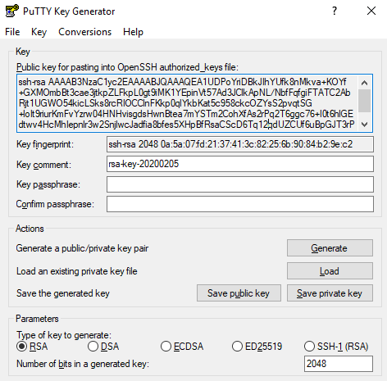

1. Save your public and private key. If you attempt to save your private key without a password it a prompt will pop up. Please put a pass phrase and then save your private key. If you don’t and someone gets your private key, they could easily log into our server and delete everything while looking like you.
2. Upload your public key to GitHub in the RSA keys directory as firstInitialLastName_key.pub